On the Characteristics of Error Functions for Neural Networks
Sang-Hoon Oh*
*Mokwon University, Korea
E-mail:shoh@mokwon.ac.kr

Introduction

We use FNN(Feedforward Neural Network) in many applications based on the proof that FNN is a universal approximator which can approximate any function with enough number of hidden nodes[1]. Rumelhart and McClelland proposed the EBP(Error Back-Propagation) algorithm to train FNN[2]. However, the EBP algorithm to minimize MSE(mean-squared error function) of FNN has a weakness with slow learning convergence and poor generalization performance[3]. There are many error functions to improve the performance of EBP algorithm[4][5]. In this paper, we investigate the characteristics of various error functions proposed for training of FNN on classification problems. Based on the result, we propose a new error function for training of FNN on regression problems including water level prediction.

Feedforward Neural Networks (FNNs)

As shown in Fig. 1, FNN consists of input vector x, hidden node vector h, output node vector y, and their connection weights. When an input vector $x=[x_{1},x_{2},⋯,x_{N}]^{T}$ is presented to the FNN, a weighted sum to $h_{j}$is given by $a_{j}=\sum{w_{\text{ji}}x_{i}}+w_{j0}$ and then the hidden node value is given by $h_{j}=\text{tanh}\left(a_{j}\right)$. Here, $w_{j0}$ is a bias and $w_{\text{ji}}$ is a weight between $h_{j}$and$x_{i}$. The k-th output node $y_{k}$ is calculated through the same procedure of weighted sum and nonlinear transform $\text{tanh}\left(\text{.}\right)$ using the weight$v_{\text{kj}}$ and the hidden node value $h_{j}$. When $t_{k}^{(p)}$ is given for a specific training sample$x^{(p)}$, we usually updates weights $w_{\text{ji}}$ and $v_{\text{kj}}$ to minimize the MSE function $E^{\text{out}}=\frac{1}{2}\sum{{\sum{\left(t_{k}^{(p)}−y_{k}^{(p)}\right)}}^{2}}$. Here, P is the number of training samples and M is the number of output nodes. EBP algorithm provides updating procedure of $w_{\text{ji}}$ and $v_{\text{kj}}$as follows[2]:
${Δv}_{\text{kj}}=−η\frac{∂E^{\text{out}}}{∂v_{\text{kj}}}={\text{ηδ}}_{k}^{(p)}h_{j}^{(p)}\text{ where }δ_{k}^{(p)}=−\frac{∂E^{\text{out}}}{∂{\hat{y}}_{k}^{(p)}}=(t_{k}^{(p)}−y_{k}^{(p)})f'({\hat{y}}_{k}^{(p)})$ (1)
${Δw}_{\text{ji}}=−η\frac{∂E^{\text{out}}}{∂w_{\text{ji}}}=ηf'({\hat{h}}_{j}^{(p)})x_{i}^{(p)}\sum{v_{\text{kj}}δ_{k}^{(p)}}$ (2)
When we adopt a linear output MLP for regression problems, $y_{k}=\sum{v_{\text{kj}}h_{j}}+v_{k0}$ and $f'\left(y_{k}\right)=1$.

Characteristics of Error Functions

Since $δ_{k}^{(p)}$ in Eq. (1) is proportional to the slope of sigmoidal activation function, updating amount of weights could be tiny in the case that output nodes are in the saturation region of sigmoidal activation function. Especially, “incorrectly saturated” output nodes retard the learning speed of EBP algorithm very slowly. In order to resolve this problem, the cross-entropy(CE) error function is defined by[6]
$E_{\text{CE}}=−\sum_{k=1}^{M}{\left[\left(1+t_{k}\right)\text{ln}\left(1+y_{k}\right)+\left(1−t_{k}\right)\text{ln}\left(1−y_{k}\right)\right]}$. (3)
However, the fact that $δ_{k}^{(p)}$ derived from Eq. (3) is only proportional to the difference between desired and real outputs suffers from overspecialization to training samples. The n-th order extension of CE (nCE) function defined by[3]
$E_{\text{nCE}}=−\sum_{k=1}^{M}{\int{\frac{t_{k}^{n+1}{\left(t_{k}−y_{k}\right)}^{n}}{2^{n−2}\left(1−y_{k}^{2}\right)}{\text{dy}}_{k}}}$ (4)

can reduce the overspecialization by weaking the updating amount of weights for correctly saturaed output node. Here, n is a natural number.
In classification applications, the output value of FNN is confined within the full region and its desired value is $±1$. Consequently, the difference between the desired and real output values is less than two. In regression problems, we use a linear output node and there is no any limitation of output values. When outliers are presented to the FNN with a linear output node, the difference between real and desired output values become very large which causes a massive updating of weights. In order to suppress the massive updating of weights by outliers, the mean log-square (MLS) error function is defined by[7]
$E_{\text{MLS}}=\sum_{k=1}^{M}{\text{ln}\left(1+\frac{1}{2}{\left(t_{k}−y_{k}\right)}^{2}\right)}$. (5)

We derive $δ_{k}^{(p)}$’s from each error function and draw them in Fig. 2 with $t_{k}^{(p)}=1\text{.}$ As previously explained, $δ_{k}^{(p)}$ for MSE approaches to zero when $y_{k}^{(p)}$is near opposite to$t_{k}^{(p)}$(“incorrcet saturation”). This retards the convergence of EBP algorithm. $δ_{k}^{(p)}$ for CE is too strong when $y_{k}^{(p)}$is to$t_{k}^{(p)}$(“corrcet saturation”). This makes FNN overspecialized. $δ_{k}^{(p)}$ for nCE is strong for incorrectly saturated output node and weak for correctly saturated output node. Since MLS is proposed for FNN with a linear output node, $δ_{k}^{(p)}$ for MLS in Fig. 2 shows that MLS is not adequate for FNN with a sigmoid output node. So, we plot $δ_{k}^{(p)}$ for MLS in FNN with a linear output node. $δ_{k}^{(p)}$ increases when $y_{k}^{(p)}$ goes far from $t_{k}^{(p)}$. However, after some increasing of $δ_{k}^{(p)}$, it resides within a confined range. This prevents massive updating of weights for outliers.

4. Discussion and Conclusion

In this presentation, we briefly introduced FNN and investigate the characteristics of MSE, CE, nCE, and MLS error functions proposed as criteria of learning.

5. References

[1] K. Hornik, M. Stinchcombe, and H. White, “Multilayer Feed-forward Networks are Universal Approximators,”
Neural Networks, vol.2, 1989, pp. 359-366.
[2] D. E. Rumelhart and J. L. McClelland, Parallel Distributed Processing, MIT Press, Cambridge, MA, 1986.
[3] S.-H. Oh, “Improving the Error Back-Propagation Algorithm with a Modified Error Function,” IEEE Trans. Neural Networks, vol.8, 1997, pp. 799-803.
[4] S.-H. Oh, “Statistical Analyses of Various Error Functions for Pattern Classifiers,” Proc. Int. Conf. Hydrid Information Tech., Sept. 22-24, Daejon, Korea, 2011, vol. 206, pp. 129-133.
[5] S.-H. Oh, “Contour Plots of Objective Functions for Feed-Forward Neural Networks,” Int. Journal of Contents, vol. 8. No. 4, pp. 30-35, 2012.
[6] A. van Ooyen and B. Nienhuis, “Improving the Convergence of the Backpropagation Algorithm,” Neural Networks, vol.5, 1992, pp. 465-471.
[7] K. Liano, “Robust Error measure for Supervised Neural Network Learning with Outliers,” IEEE Trans. Neural Networks, vol.7, 1996, pp. 246-250.

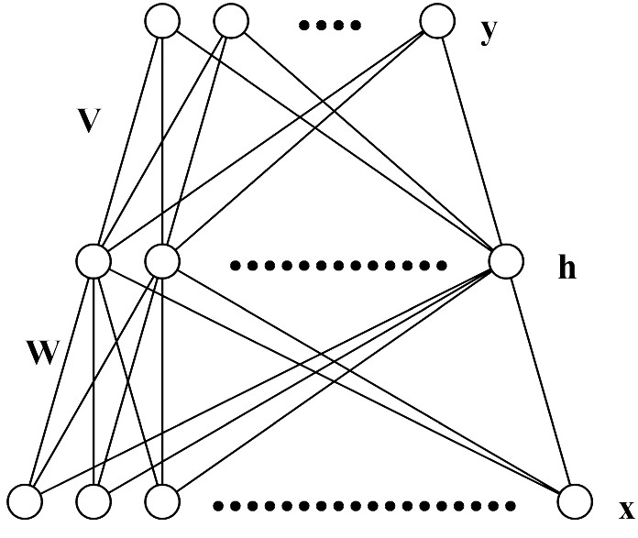
Figure 1 The architecture of FNN.
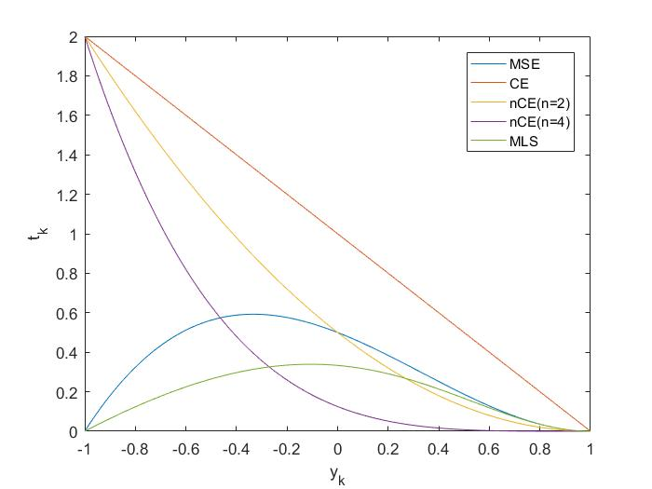

Figure 2 The plot of delta signal for various error functions when $t_{k}=1\text{.}$

