Improving the Subject-Independent Classification of Implicit Intension
Sang-Hoon Oh*
*Mokwon University,Korea
E-mail:shoh@mokwon.ac.kr

Introduction

Brain computer interfaces (BCIs) have focused on recognizing and responding to explicitly-expressed intentions. Surprisingly, there have been a few research to recognize humans’ implicit intention [1][2][3]. The implicit intention can be categorized into unexpressed and hidden intention. The hidden intention corresponds to whether or not a human’s explicitly-expressed intention is the same as the actual intention [1]. The unexpressed intention is whether or not a human agrees with the others during conservation or sentence reading [2].
Since electroencephalography (EEG) has non-invasive nature and high temporal resolution, many BCI technologies are based on EEG signals. Most recently, Dong et al. focused on the second category of implicit intention and reported the EEG-based classification of implicit intention during self-relevant sentence reading [2]. However, the best classification accuracy of 75.5% belongs to a subject dependent classification. This means that we can only classify the implicit intention of users whose EEG signals have been already recorded and analyzed. For classifying implicit intention of unanalyzed users, we need a subject independent classifier. In this point of view, the subject independent classification was tried and showed that the accuracy on the same task is 65.3% with the theta component [3]. In this paper, we improve the subject independent classification of EEG signals through sample generation based on PCA (principal component analysis) [4] and ICA (independent component analysis) [5].

EEG Signals for Implicit Intension

We use the EEG signals for implicit intention provided by CNSL, KAIST [2]. The EEG signals were measured from nine healthy right-handed Korean subjects. For each subject, an experimental session consisted of 74 trials. The seventy four stimulating sentences for trials were selected from the Minnesota multiphasic personality inventory-II (MMPI-II), one of the most frequently used standardized psychometric tests. All sentences were converted to contents block with SOV topology like ‘The experience of worrying over money’ and sentence-ending block such as ‘do exist’ or ‘do not exist’. After showing the contents block for four seconds and the sentence-ending block for two seconds, an asterisk image was presented for two seconds and subjects were instructed to answer whether or not they agreed with the statement. Here, the mission is to classify the subject’s implicit intention of ‘agreement’ and ‘disagreement’ by EEG signals during reading of contents block.
The EEG signals were recorded using the BrainAmp system and an EEG cap with thirty two electrodes. Thirty electrodes were placed on each subject’s scalp as shown in Fig. 1 and two electrodes were positioned below subject’s left eye and left collarbone to record electrooculogram (EOG) and electrocardiogram (ECG), respectively. After removing artifacts from eye blinking, eye movement, and heartbeats by independent component analysis (ICA) algorithm [5], the time-frequency representations of the thirty EEG signals from subjects’ scalp were extracted by Morlet wavelet transform. Based on fMRI studies with similar experiments, the yellow electrodes in Fig. 1 were used to find effective time-frequency components. Consequently, five time-frequency components were selected as (1) the gamma component (35Hz-45Hz) in 350~550ms, (2) the beta2 component (20Hz-26Hz) in 300~450ms, (3) the beta1 component (14Hz-17Hz) in 800~1,000ms, (4) the alpha component (9Hz-12Hz) in 300~700ms, and (5) the theta component (5Hz-7hz) in 400~1,000ms after the onset of the contents [2].

Improving the Classification of Implicit Intension with PCA and ICA

As explained in the introduction, we reported that subject independent classification accuracy of the implicit intention is 65.3% which are about 10% below of the subject dependent classification accuracy. Classification accuracy using machine learning models depends on the number of training samples. Therefore, in order to improve the classification ratio, we generate training samples based on PCA and ICA as following procedure.
[Sample Generation and Classifier Training Procedure]
Step 1: Conduct PCA on 150-dimensional EEG data with the five components, which gives eigenvectors and corresponding eigenvalues. Then, project the 150-dimensional EEG data to 50-dimansional data using 50 eigenvectors that correspond to the largest 50 eigenvalues among 150 ones. This corresponds to the output of PCA network.
Step 2: Train a 50ⅹ50 ICA network with the 50-dimensional data to find out independent components.
Step 3: Add Gaussian noises to the outputs of ICA network for each training sample.
Step 4: Reversely project the ICA output data with Gaussian noises on the input layer of ICA network, which corresponds to the 50 dimensional output of PCA network.
Step 5: After zero-padding of 100-dimension, project the output of PCA on the input layer of PCA. This is the training sample generation based on PCA and ICA.
Step 6: Repeat Step 3~Step 5 for whole training samples.
Step 7: Train a subject independent classifier with whole training and generated samples.
We use SVM (support vector machine) with Gaussian kernels as a classifier, since it shows better performance with less training samples. As shown in Fig. 2, SVM can find out optimal maximum margin hyperplane with support vectors to classify two classes.
In simulations, Gaussian noises with various values of standard deviation are added to the output of ICA network. Also, many times of training samples are used for sample generation. When three times of whole training samples are used for sample generation with the standard deviation of six times of the 50th component of PCA, we attained the subject independent classification accuracy of 66.7% with the gamma component of four electrodes which are selected through analysis of Fisher’s score.

4. Discussion and Conclusion

In this presentation, we briefly introduced classification of implicit intention based on EEG signals and improved the subject independent classification of implicit intention through sample generation. Through dimensional reduction of EEG data followed by ICA, we acquired independent components. Adding Gaussian noises to the outputs of ICA network, we generated many samples. These were reversely projected to EEG data domain and used for training of SVM classifier with Gaussian kernels. Our strategy improved the subject independent classification accuracy of implicit intention from 65.3% to 66.7%. We verified that sample generation through PCA and ICA can improve the classification accuracy of implicit intention.

5. References
[1] C. Davatzikos et al, “Classifying Spatial Patterns of Brain Activity with Machine Learning Methods: Application to Lie Detection,” Neuroimage, vol. 28, pp. 663-668, 2005
[2] S.-Y. Dong, B.-K. Kim, and S.-Y. Lee, “EEG-based Classification of Implicit Intention during Self-relevant Sentence Reading,” IEEE Trans. Cybernetics, Accepted for publication.
[3] S.-H. Oh, “Subject Independent Classification of Implicit Intention Based on EEG Signals,” Int. J. of Contents, vol. 12, no. 2, pp. 12-16, 2016.
[4] S. Haykin, Neural Networks, Macmillan College Publishing Company, Inc, 1994.
[5] T.-W. Lee, et al., “A unifying information theoretic framework for independent component analysis,” Computers & mathematics with Applications, vol. 31, no. 11, pp. 1-21, 2000.

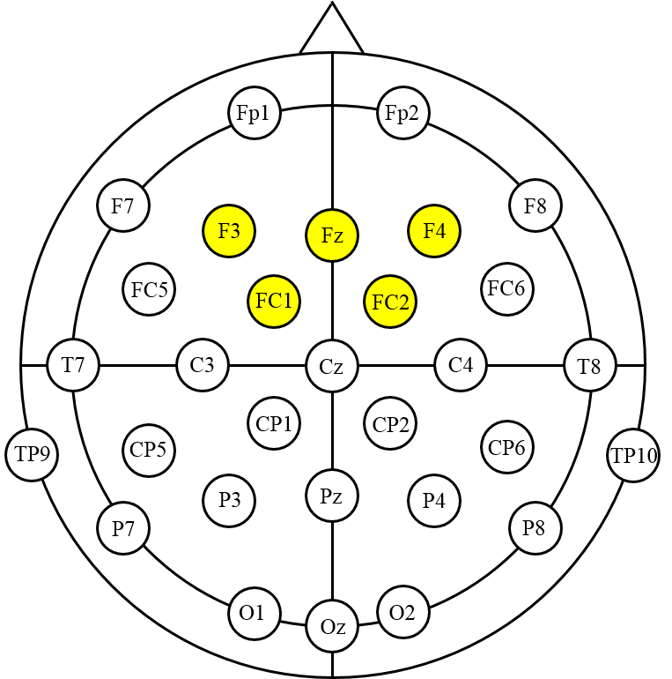
Figure 1. The location of thirty electrodes on a subject’s scalp. The yellow electrodes were used to find effective time-frequency components.

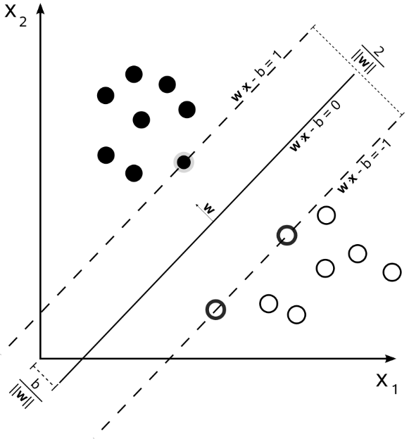
Figure 2 Optimal maximum margin hyperplane of two classes. Samples on the margin correspond to support vectors.

