Predicting the Water Level in Andong Region
Sang-Hoon Oh*, Hiroshi Wakuya**
*Mokwon University,Korea, **Saga University, Japan
E-mail:shoh@mokwon.ac.kr, wakuya@cc.saga-u.ac.jp

Introduction

Andong is a very important region because of UNESCO world heritage site, “Hahoe Village.” For protecting the site from severe disasters, we must consider DPD(Disaster Prevention Design) in “Hahoe Village.” Among various disasters, flooding has been focused because of its drastic impact on lives and properties in wide area. It is estimated that of the total economic loss caused by all kinds of disasters, 40% are due to flooding. However, the relationship between rainfall and flood discharge is very complex[1]. Therefore, modelling the relationships between rainfall and flooding or runoff are still unsolved problems[2-7].
There have been increasing of interest in artificial neural networks(ANNs) because of their information processing capability through learning from exemplars[8]. When modelling a phenomena using ANNs, it is not necessary to elucidate complex mechanisms involving the phenomena[6]. In this point of view, ANN has been widely applied in hydrology. In this presentation, we propose an ANN for predicting the water level of Nakdong river in Andong region. That is, the water level of Nakdong river near “Hahoe Village” is predicted with rainfalls in Andong region.

Artificial Neural Networks (ANNs)

ANNs are models imitating neural networks in human brain which are capable of high level information processing[8]. They can be categorized into unsupervised and supervised models. Supervised models learn from exemplars with their targets, which are desired output values when the exemplars are presented to the supervised neural network model. On the contrary, unsupervised models learn from exemplars without any target. Self-organizing feature map and independent component analysis belong to the unsupervised model. Gaussian potential function network and multi-layer perceptron (MLP) are representative supervised models. Especially, based on the proof that MLP can approximate any function with enough hidden nodes, MLP has been applied to many fields such as pattern recognition, time series prediction, fraud detection, hydrology etc.
Fig. 1 shows the architecture of MLP consisted of input vector x, hidden node vector h, output node vector y, and their connection weights. When an input vector $x=[x_{1},x_{2},⋯,x_{N}]^{T}$ is presented to the MLP, a weighted sum to $h_{j}$is given by $a_{j}=\sum{w_{\text{ji}}x_{i}}+w_{j0}$ and then the hidden node value is given by $h_{j}=\text{tanh}\left(a_{j}\right)$. Here, $w_{j0}$ is a bias and $w_{\text{ji}}$ is a weight between $h_{j}$and$x_{i}$. The k-th output node $y_{k}$ is calculated through the same procedure of weighted sum and nonlinear transform $\text{tanh}\left(\text{.}\right)$ using the weight$v_{\text{kj}}$ and the hidden node value $h_{j}$. When $t_{k}^{(p)}$ is given for a specific training exemplar$x^{(p)}$, we usually updates weights $w_{\text{ji}}$ and $v_{\text{kj}}$ to minimize the mean-squared error function $E^{\text{out}}=\frac{1}{2}\sum{{\sum{\left(t_{k}^{(p)}−y_{k}^{(p)}\right)}}^{2}}$. Here, P is the number of training exemplars and M is the number of output nodes. The error back-propagation (EBP) algorithm provides updating procedure of $w_{\text{ji}}$ and $v_{\text{kj}}$as follows[8]:
$$\begin{aligned}{Δv}_{\text{kj}}=−η\frac{∂E^{\text{out}}}{∂v_{\text{kj}}}={\text{ηδ}}_{k}^{(p)}h_{j}^{(p)}\text{ where }δ_{k}^{(p)}=−\frac{∂E^{\text{out}}}{∂{\hat{y}}_{k}^{(p)}}=(t_{k}^{(p)}−y_{k}^{(p)})f'({\hat{y}}_{k}^{(p)}) \\ {Δw}_{\text{ji}}=−η\frac{∂E^{\text{out}}}{∂w_{\text{ji}}}=ηf'({\hat{h}}_{j}^{(p)})x_{i}^{(p)}\sum{v_{\text{kj}}δ_{k}^{(p)}}\end{aligned}$$
Since we adopt a linear output MLP for predicting the water level of Andong, $y_{k}=\sum{v_{\text{kj}}h_{j}}+v_{k0}$ and $f'\left(y_{k}\right)=1$.

3. Hydrological Modelling of Andong Region Using MLPs

Here, we propose a hydrological modelling of Andong region, that is, the relationship among the water level of Gudam and the rainfalls of Pungsan, Iljik, and Andong (their locations are indicated by “red circles” in Fig. 2). During 2012, 2013, and 2014 years, the rainfalls of Pungsan, Iljik, and Andong had been recorded in the period from March 1st to November 30th with the interval of one hour. Also, the water level of Gudam had been recorded in the same period. Therefore, each data file has 6600 records in each year.
For modelling the hydrological relationship among the water level and rainfalls using MLP with a linear output, the correlation coefficient among the water level of Gudam and the rainfalls at the three locations are investigated and we select the delay of 40 hours is enough for the modelling. Therefore, the three rainfall data and the water level of Gudam at n-1, n-2,…n-40 are presented to the input layer of MLP and the water level of Gudam at n is presented as a target value of MLP output. EBP algorithm updates the weights of MLP to predict the water level after one hour.
MLP with 160 inputs, 40 hidden nodes, and one output node is initialized with the weights uniformly distributed on $\left[−1×{\text{10}}^{−4},1×{\text{10}}^{−4}\right]$. We adopt a learning rate of 0.01. The MLP is trained with the data in 2012 and 2013 and tested with the data in 2014 for performance evaluation of MLP. We estimate the correlation coefficient between the water level of Gudam and its predicted value as a performance measure. After training of 10000 iterations, the correlation coefficient is 0.9832. Fig. 3 shows the prediction results for 2014 and Fig. 4 shows the result for a specific period from 8/16 18:00 to 8/20 22:00. Thus, we can argue that MLP successfully predicts the water level of Gudam.

4. Discussion and Conclusion

In this presentation, we briefly introduced ANNs and proposed a hydrological model of Andong region using MLP. The MLP was trained with the water level and rainfalls during 2012 and 2013, and then tested with them in 2014. Predicting the water level of Gudam after one hour with the rainfalls of Andong, Pungsan, and Iljik was successful.

5. Acknowledgement
This work was supported by the National Research Foundation of Korea Grant funded by the Korean Government (NRF-2014K2A2A4001441).

6. References
[1] H. L. Cloke and F. Pappenberger, “Ensemble flood forecasting: A review.” Journal of Hydrology, vol. 375, pp. 63-626, 2009.
[2] L.-H. Feng anf J. Lu, “The practical research on flood forecasting based on artificial neural networks,” Expert Systems with Applications, vol. 37, pp. 2974-2977, 2010.
[3] C. W. Dawson, R. J. Abrahart, A. Y. Shamseldin, and R. L. Wilby, “Flood estimation at ungauged sites using artificial neural networks,” Journal of Hydrology, vol. 319, pp. 391-409, 2006.
[4] C. W. Dawson and R. L. Wilby, “Hydrological modelling using artificial neural networks,” Progress in Physical Geography, vol. 25, pp. 80-108, 2001.
[5] Y. Wei, W. Xu, Y. Fan, and H.-T. Tasi, “Artificial neural network based predictive method for flood disaster,” Computers & Industrial Engineering, vol. 42, pp. 383-390, 2002.
[6] S. Raid, J. Mania, L. Bouchaou, and Y. Najjar, “Rainfall-runoff model using an artificial neural network approach,” Mathematical and Computer Modelling, vol. 40, pp. 839-846, 2004.
[7] S. Raid, J. Mania, L. Bouchaou, and Y. Najjar, “Predicting catchment flow in a semi-arid region via an artificial neural network,” Hydrological Processes, vol. 18, pp. 2387-2393, 2004.
[8] R. P. Lippmann, “An introduction to computing with neural nets,” IEEE ASSP Magazine, pp. 4-22, April, 1987.

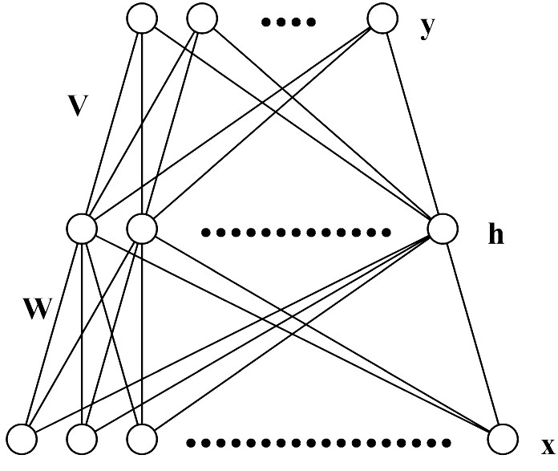
Figure 1 The architecture of MLP.

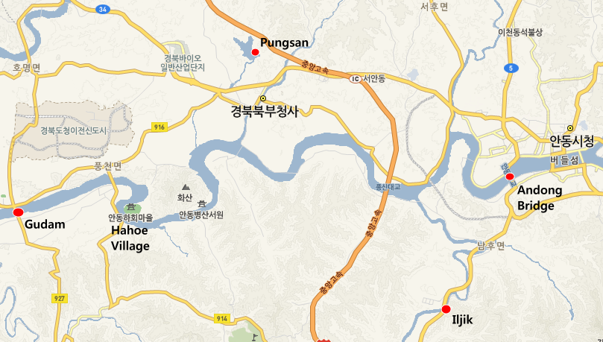
Figure 2 The location of Gudam, Pungsan, Iljik. And Andong (indicated by “red circles”).

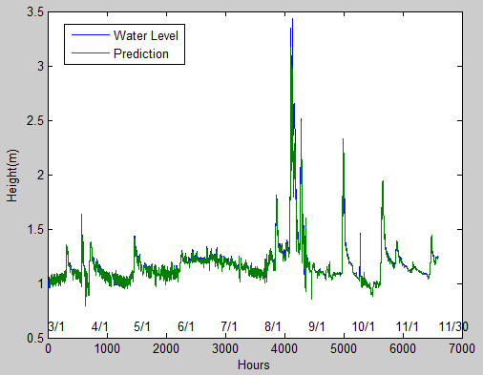
Figure 3. Prediction results for 3/1~11/30, 2014.

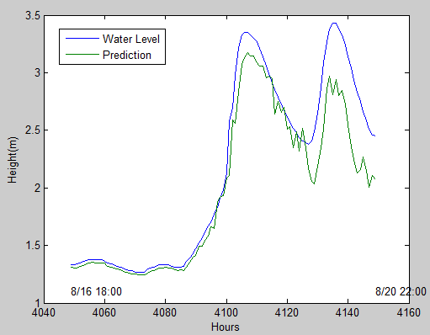
Figure 4. Prediction results for 8/16~8/20.

